Experiments with the HoloEye LCD spatial light modulator
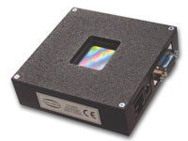HoloEye model LC2002 spatial light modulator

The HoloEye (http://www.holoeye.com/spatial_light_modulator_lc_2002.html) LC 2002 Spatial Light Modulator (SLM) contains a Sony SVGA (800x600 pixels) liquid crystal microdisplay and drive electronics. It can be used with a standard personal computer or laptop by plugging the device to a VGA graphics connector. The phase distribution of a beam input to the SLM can be modulated by a voltage on the electrodes (800x600 pixels) of the LCD. The phase modulation is a side-effect of the liquid crystal material and is caused by its birefringence property. It yields a more or less linear phase shift with voltage of maximum 2π radians at 532 nm. This phase shift is used to introduce a phase modulation of a coherent input beam by setting a voltage on each pixel of the modulator. In this exercise three different phase distributions are used leading to a ring-shape intensity distribution, a diffractive optical element (DOE) acting as a positive lens and a phase hologram respectively. These phase distributions are calculated with Matlab programs provided. Also, simulations can be performed using LightPipes for Matlab (Practicum version).

Initial instructions:
- Complex amplitude.
A coherent beam of light can be described by its complex amplitude distribution: 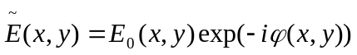. E₀(x,y) and ϕ(x,y) are the amplitude and phase as a function of the transverse coordinates. The amplitude can be determined easily with screens or CCD cameras by taking the square root of the intensity distribution. The phase distribution is much more difficult to measure. The phase, however, plays an important role and can never be neglected in optics. A lens, for example, will change the phase distribution but leaves the amplitude distribution unaltered.
- Phase distribution of a lens.
The phase distribution of a coherent monochromatic light beam after passing a lens can be calculated by considering the optical paths of rays through the lens. The phase can be found by calculating the optical path of a ray parallel to and at r above the optical axis. It is (glass + air): , with: 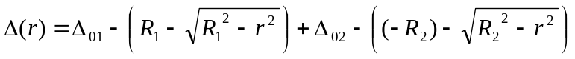, and 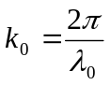, the propagation constant in vacuum. This can be approximated (by expanding the square roots) to: 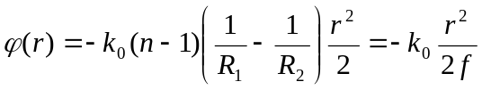, with 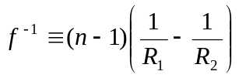, the ‘lens-makers formula’ for the focal length of a thin lens. Note the sign conventions for the lens radii. (The constant phase, 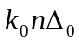 is not relevant and can be neglected.) This formula is used in the Matlab programs and is executed by the LightPipes for Matlab ‘F=LPLens(f,0,0,F)’ command, which inserts a lens at the optical axis in the field (complex amplitude) F .
The ray-angle with the optical axis is: 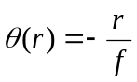. So, as expected, all rays point to a single point on the optical axis, the focal point of the lens. The approximation made holds for rays close to the optical axis (small angles) and is called the ‘paraxial approximation’. If the approximation is not valid, we are dealing with (spherical) aberration and the rays to far from the axis will not pass through the paraxial focal point.
r
R₂<0
Δ₀₁
Δ₀₂
R₁>0
Δ₀
θ
Focal point
- Phase distribution of an axicon.
An axicon is a conical optical element as shown in the figure below. To find the phase distribution and the ray-angles, θ(r), after passage through the axicon, a similar calculation as with the lens can be performed. Calculate the phase distribution (paraxial approximation) and show that the ray-angles are given by: 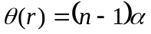, with 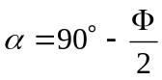, the sharp angle of the axicon and n the refractive index of the axicon material.
r
θ(r)
α
Φ
n
- Connection of the HoloEye spatial light modulator (SLM) to your laptop.
The HoloEye SLM can be operated by your laptop by simply connecting it to the extra VGA port on your laptop (normally used for beamers). The set-up you use is shown in figure 1. Fig. 1. Set-up of the experiments with the SLM.
You have to set your laptop in ‘dual monitor’ mode. This is probably done by pressing the ‘F8’ key a few times. Furthermore the second monitor must be set to 800 x 600 pixels with 256 bit color depth. This can be done by running your graphics driver software on your PC. Probably it can be accessed by left-clicking on your desktop. The voltage on the LCD pixels is proportional to the gray levels (0-255) of the image displayed on the HoloEye ‘second monitor’. Once the HoloEye has been connected to your laptop you should plug-in the power supply cable of the HoloEye. Run the Matlab ‘Axicon.m’ program to test the SLM. A ring should appear in the focus of the 400 mm lens placed behind the SLM. Sometimes it is necessary to un-plug the power cable and to plug it in again to reset the SLM.
screen
f=400mm
f=300mm
f=10mm
VGA cable
laptop
HoloEye LC 2002 spatial light modulator

HeNe laser

Assignment 1. Determination of the pixel spacing of the LC2002.
Build the setup shown in figure 1.
- Start with the HeNe laser. It must be aligned parallel to the optical rail.
- Place the 10mm lens and adjust its position such that the expanded beam does not deflect.
- Place the 300mm lens and verify that the expanded beam does not deflect and is not diverging or converging. Check the distance between the 300 and 10 mm lenses. What distance do you expect?
- Place the HoloEye modulator such that the beam fills the whole aperture of the device.
- Place the 400mm lens and place a white or mm screen in its focal plane.
- You should observe an array of bright spots.
What is the cause of the array of bright spots? Determine the spacing of the pixels of the SLM.

Assignment 2. Holographic Optical Element (HOE).
In this assignment we are going to make a holographic optical element which has the same function as that of a positive lens. This hologram can be made in practice by letting coherent light originating from a point source and that of a plane wave to interfere as shown in figure 2. Of course the initial phases of the two beams must be stationary, which is best organized by originating them somehow from the same source.
Fig. 2. Recording of a hologram acting as a HOE lens.
Once the interference pattern (intensity distribution) on the photographic plate has been transformed into a phase pattern (this can be done by etching the surface of a glass plate, i.e. transforming the gray levels of the intensity pattern into hills and valleys in the glass, causing fluctuations in the local optical path lengths and hence in phase fluctuations of an incoming beam of light).
As an alternative, the phase distribution of the interfering beams can also be programmed in the SLM. The hologram can be compared to a Fresnel zone phase plate in (see Hecht 4th ed., chapter 10.3.5) in which the λ /2 rings are replaced by smooth cosine functions. Figure 3 shows a cross section of such a phase plate. 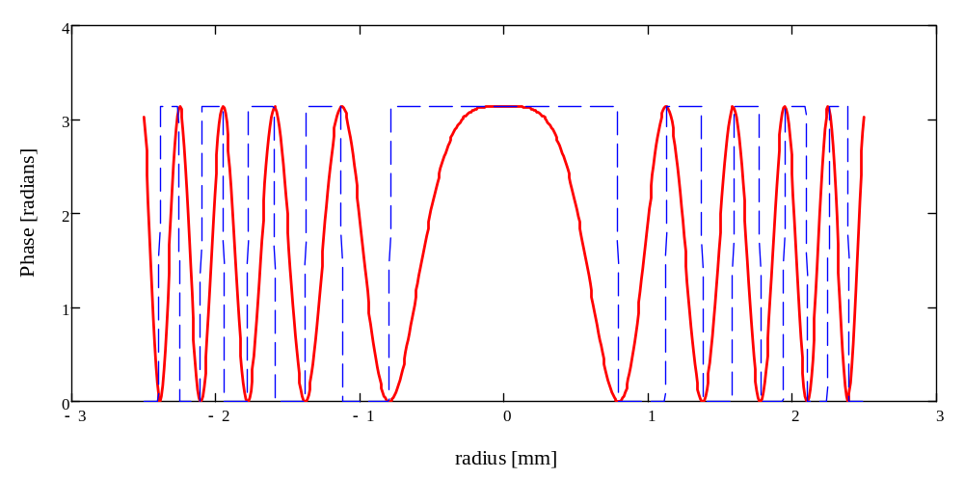
Fig. 3. Cross section of a cosine phase plate (red). The blue curve is a Fresnel zone plate. (Here the plot must be considered as a set of concentric annular screens blocking the odd Fresnel zones and passing the even zones or annular structures producing a λ/2 phase jump from zone to zone.) f = 1 m, λ = 632.8 nm.
The phase as a function of the radius is given by: 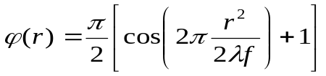, where f is the desired focal length of the HOE lens.
Plane wave
spherical wave

Photographic plate
- Use the set-up shown in figure 1 but with the f=400mm lens removed.
- Use the Matlab ‘HOElens.m’ program to verify the theory.
- If you like, play with the LightPipes simulation.
- A disadvantage of the holographic lens is that it has low efficiency because there is not only a converging beam, but also a diverging and a plane wave emerging from the holographic lens. Modify the Matlab program such that the phase distribution of a thin lens is transferred to the SLM.

Assignment 3. Hologram of a 2D picture.
Here you learn how to make a computer generated 2D hologram using the so-called Gerchberg-Saxton algorithm. This an iterative process in which Fourier and inverse Fourier transforms are taken after substituting the intensity pattern of the input wave and the desired pattern at each iteration step keeping the phase distribution unchanged.
Input wave (here plane wave: amplitude = 1, phase = 0)
Take 2-D Fourier transform
Substitute desired intensity distribution, leave phase unchanged
Take 2-D Inverse Fourier transform
Substitute input intensity distribution, leave phase unchanged
Fig. 4. Gerchberg-Saxton algorithm to calculate a phase hologram. See the Matlab ‘Hologram.m’ document for details.

Try several examples included and see what happens when you increase the number of iterations. If the HoloEye SLM is connected, you have to perform the 2-D Fourier transform (line 58 in the program) optically to see the image on a screen. How can you do that?

Assignment 4. Ring focus with an axicon and a positive lens.
A ring focus can be made using an axicon followed by a positive lens. In the focal plane of the lens a ring shaped intensity distribution will appear. An axicon is a cone-shaped optical element as depicted in figure 4. In this assignment we are programming the phase distribution of an axicon and a positive lens in the SLM. This will be done using (part) of the LightPipes optical toolbox ‘LightPipes for Matlab’. The Matlab program calculates the propagation of a plane monochromatic wave through an axicon and a lens. The phase distribution is extracted from the complex amplitude and displayed in a Matlab figure. This figure, with gray values from 0 (black) to 255 (white) is loaded into the SLM and a collimated beam will be transformed into a ring at the focal plane of the lens.
- Use the set-up build in assignment 1.
- Remove the 400 mm lens because a lens will be programmed in the SLM.
- Run the ‘Axicon.m’ Matlab program.
- Measure for various values of the top-angle of the axicon and focal lengths of the lens the diameter of the ring.
- Derive an expression for the ring diameter for an axicon with top-angle, φ, and refractive index, n, and a lens with focal length, f.
- Compare the measurements with the calculations. (Use a graph to present the results).
- Place the 400 mm lens back in the set-up and remove the lens in the Matlab program (just put a comment (%) in front of the command).
- Repeat the measurements and compare again with the calculations.
Remarks:
  - If the top angle of the axicon is too small, the ring will be larger than the spacing between the orders of the grating due to the pixels of the SLM and overlap of rings will occur. Can you derive an expression of the minimum allowed axicon top angle for our 600 x 600 / 19.2mm x 19.2mm grid?
  - You can also simulate the set-up and compare with the experiments using LightPipes for Matlab. Un-comment the appropriate lines in the ‘Axicon.m’ program. You must increase the focal length of the lens (f~1000mm) and the top angle (~179 deg) in the program because of the limitation of the grid.
  - Besides a phase modulation, our SLM also changes the local polarization of the beam. You can use a polarizer to enhance the contrast. Also rotate the laser to change and optimize its polarization. Where must the polarizer be placed? Can you give an explanation?
  - For those who are interested in modern optics: It is possible to simulate with the ‘Axicon.m’ program a so-called Bessel-beam. (See Hecht Optics 4th edition, chapter 10.2.7. The axicon method is even ‘more elegant’ than the annular slit described in Hecht, because no beam power is wasted by the annular slit). These Bessel beams do not diffract and have a constant beam size during propagation over very long distances (several meters) in free space. Simply remove the lens in the simulation by commenting the appropriate command line (line 30). Now f is the distance where the Bessel intensity profile has to be observed. Use large top angles (>179.7 deg) to get a reasonable resolving power with our 600 x 600 grid. Try to observe the Bessel beam experimentally as well by removing the 400 mm lens from the set-up.

